**Project Documentation**

Insight Stream-Navigate the News Landscape

**1. Introduction**

• **Project Title:** Insight Stream:Navigate the News Landscape

• **Team ID:NM2025TMID36986**

• **Team Leader:**R E Jayasree& **E:** [regotijayasreeregotijayasree@gmail.com](mailto:rjeevapriyarajamurugan@gmail.com)

• **Team Members:**

-**R Jeeva priya** & **E:** [rjeevapriyarajamurugan@gmail.com](mailto:rjeevapriyarajamurugan@gmail.com)

- **S Jeeva** & **E:** [jeevasukumar378@gmail.com](mailto:jeevasukumar378@gmail.com)

-**E Kalaivani** & **E:** [keerthikalai1319@gamil.com](mailto:keerthikalai1319@gamil.com)

**2. Project Overview**

**Purpose**: The primary objective of InsightStream is to establish a user-friendly platform tailored for individuals who are passionate about staying informed, exploring diverse news topics, and accessing the latest updates.

**Our objectives include:**

* **User-Friendly Experience:** Develop an interface that is intuitive and easy to navigate, ensuring users can effortlessly access, save, and share their preferred news articles**.**
* **Comprehensive News Management:** Provide robust features for organizing and managing news content, incorporating advanced search options for a personalized news experience.
* **Technology Stack:** Employ cutting-edge web development technologies, such as React.js, to ensure an efficient and enjoyable user interface.

**3. Architecture**

• **Frontend :** React.js with Bootstrap and Material UI

• **Backend :**  Node.js and Express.js managing server logic and API endpoints

• **Database :** MongoDB stores user profiles, articles, categories, and comments

#### 4.Setup instructions

#### the key prerequisites for developing a frontend application using [React.js](http://react.js):

#### Node.js and npm: Node.js is a powerful JavaScript runtime environment that allows you to run JavaScript code on the local environment. It provides a scalable and efficient platform for building network applications.

#### Install Node.js and npm on your development machine, as they are required to run JavaScript on the server-side.

#### Download: <https://nodejs.org/en/download/>

#### Installation instructions: <https://nodejs.org/en/download/package-manager/>

#### React.js: React.js is a popular JavaScript library for building user interfaces. It enables developers to create interactive and reusable UI components, making it easier to build dynamic and responsive web applications.

#### Install React.js, a JavaScript library for building user interfaces.

#### Create a new React app:

#### npx create-react-app my-react-app

#### Replace my-react-app with your preferred project name.

#### Navigate to the project directory:

#### cd my-react-app

#### Running the React App:

#### With the React app created, you can now start the development server and see your React application in action.

#### Start the development server:

#### npm start

#### This command launches the development server, and you can access your React app at http://localhost:3000 in your web browser.

#### HTML, CSS, and JavaScript: Basic knowledge of HTML for creating the structure of your app, CSS for styling, and JavaScript for client-side interactivity is essential.

#### Version Control: Use Git for version control, enabling collaboration and tracking changes throughout the development process. Platforms like GitHub or Bitbucket can host your repository.

#### Git: Download and installation instructions can be found at: <https://git-scm.com/downloads>

#### Development Environment: Choose a code editor or Integrated Development Environment (IDE) that suits your preferences, such as Visual Studio Code, Sublime Text, or WebStorm.

#### Visual Studio Code: Download from <https://code.visualstudio.com/download>

#### Sublime Text: Download from <https://www.sublimetext.com/download>

#### WebStorm: Download from [https://www.jetbrains.com/webstorm/](https://www.sublimetext.com/download)

**To clone and run the Application project from GitHub:**

**Follow below steps**

* **Install Dependencies:**
  + **Navigate into the cloned repository directory and install libraries:**

**cd news**

**npm install**

* **Start the Development Server:** 
  + **To start the development server, execute the following command:**

**npm start**

* **Access the App: Open your web browser and navigate to http://localhost:3000.**

**You have successfully installed and set up the application on your local machine. You can now proceed with further customization, development, and testing as needed.**

* **Installation steps:**

1. **Open the project folder to install necessary tools**

**In this project, we use:**

* **React Js**
* **React Router Dom**
* **React Icons**
* **Bootstrap/tailwind css**
* **Axios**
* **For further reference, use the following resources**
* [**https://react.dev/learn/installation**](https://react.dev/learn/installation)
* [**https://react-bootstrap-v4.netlify.app/getting-started/introduction/**](https://react-bootstrap-v4.netlify.app/getting-started/introduction/)
* [**https://axios-http.com/docs/intro**](https://axios-http.com/docs/intro)
* [**https://reactrouter.com/en/main/start/tutorial**](https://reactrouter.com/en/main/start/tutorial)

**5. Project Structure** 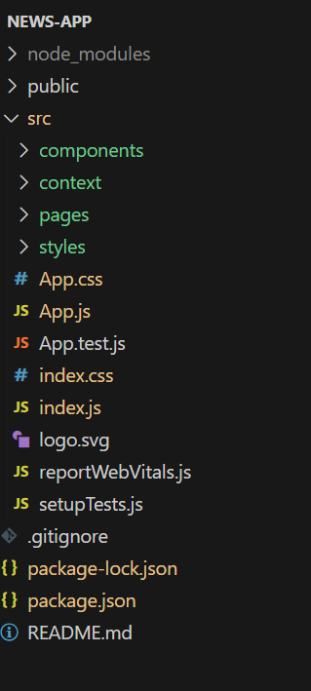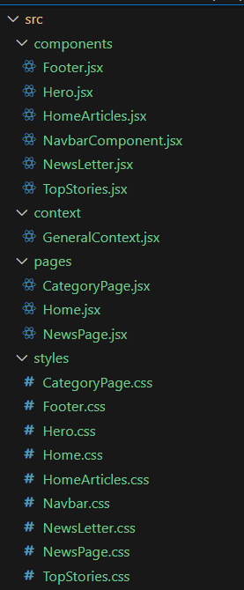

**In this project, we’ve split the files into 4 major folders, *Components, Context, Pages and Styles.* In the pages folder, we store the files that acts as pages at different URLs in the application. The components folder stores all the files, that returns the small components in the application. The context Api will be coded in the context folder. All the styling css files will be stored in the styles folder.**

**6. Running the Application**

• **Frontend:**

**cd code**

**npm install**

**npm start**

**cd server npm**

**start**

• **Access: Visit http://localhost:3000.**

**7. Testing**

• Manual testing during milestones

**11. Screenshots or Demo**

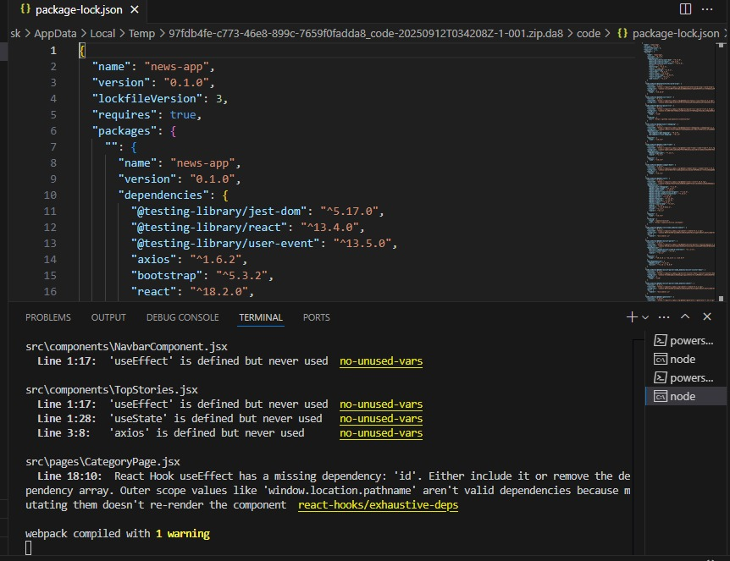

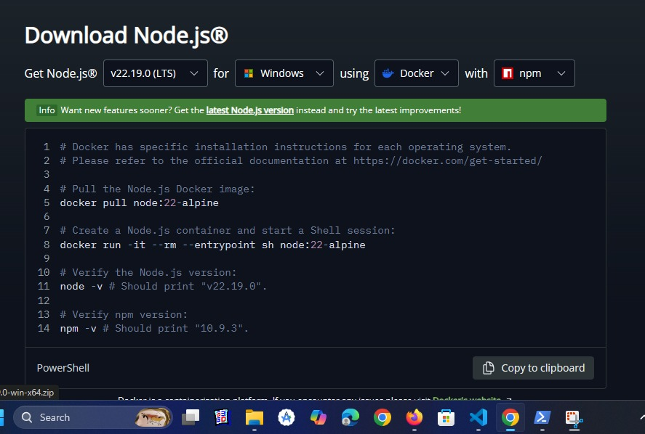

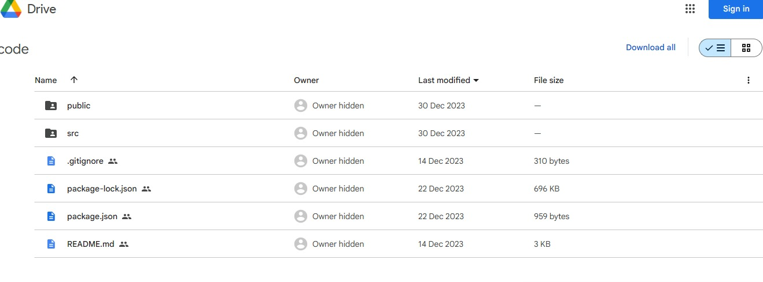

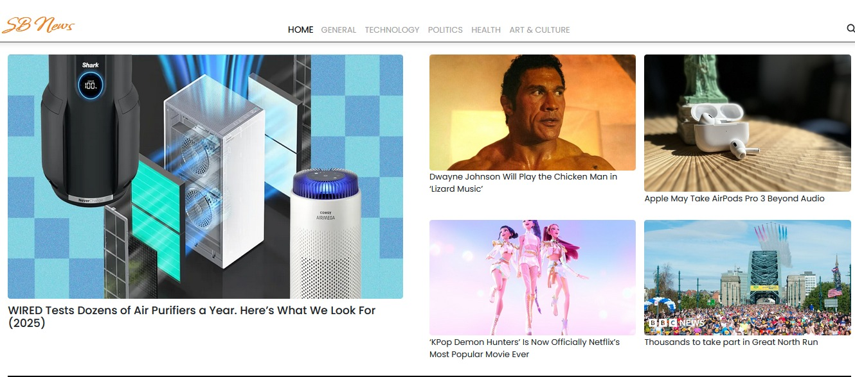

* Hero components

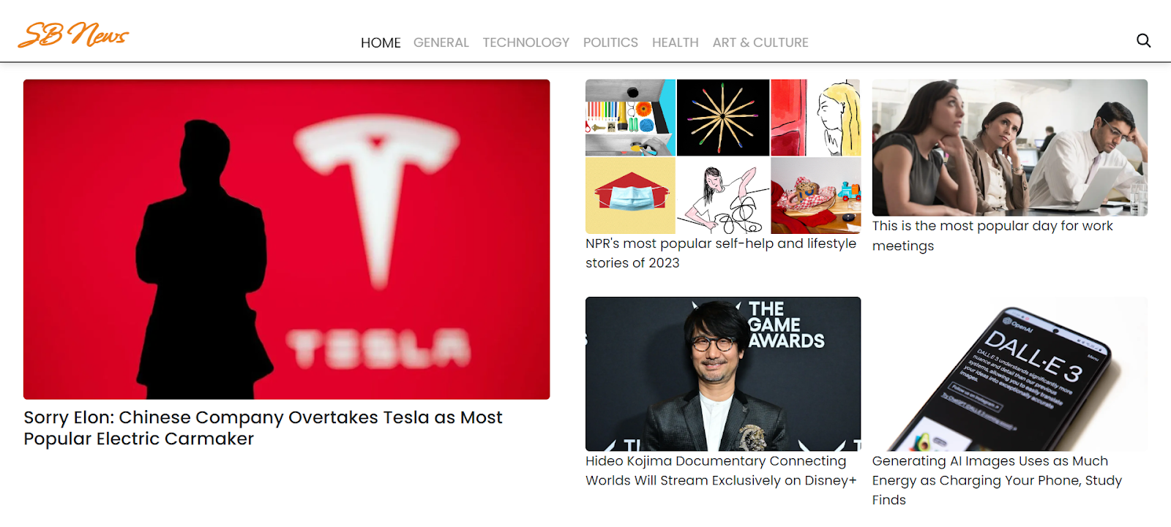

* Popular categories

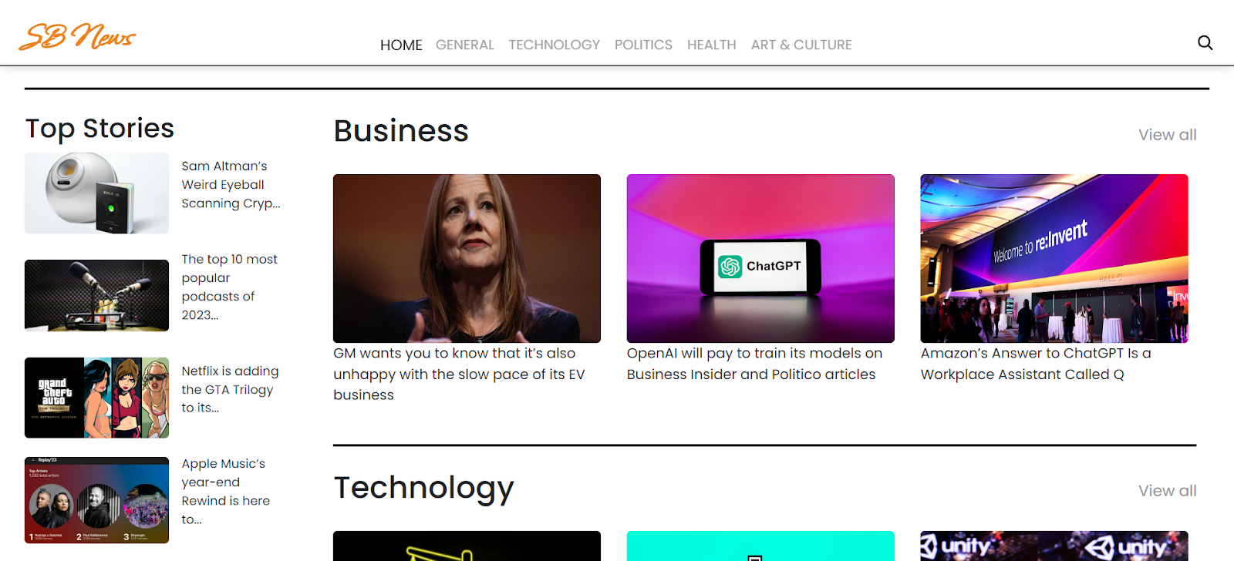

* Newsletter



* Category/Search result page

